NAKURU CITY BOARD KEY STAFF

S/ No | Name | Details of qualifications and experience
1. | Gitau Thabanja  Manager, City of Nakuru   | Gitau Thabanja is the Manager, Nakuru City and act as the Secretary to the Board. He implements the Board`s resolutions and also oversees the management and affairs of the city.  He is an Urban Planner, with a Master’s degree in Urban Administration and Planning from the esteemed University of Seoul, South Korea.  He has also been a CECM Land, Housing, and Physical Planning, Nyandarua County.
2. | Planner Robert Kiprono  Head of City Planning   | Mr. Robert Kiprono Rutto is a registered physical planner. He holds a M.A (Urban and Regional Planning) from University of Nairobi.  He has extensive experience in land use planning, physical development plan preparation, master planning, spatial planning et. He has served in various positions in national government and county government of Nakuru.
3. | CPA Mary Kagonya  Head of Accounting  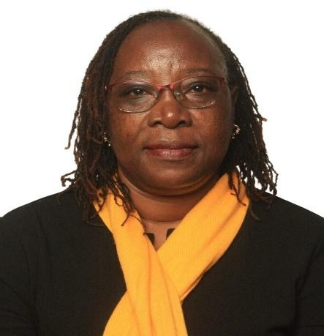 | Mary Kagoya is a CPA with a robust background in leadership and financial management. She served as the Gender Representative for the ICPAK Central Rift Branch from 2017 to 2023. In addition, she was the Deputy President for SMC No. 27 and the Treasurer for the Centre Management Committee of Friends Church, Nakuru. She has also held a key position as a Board Member at St. Xavier’s High School, Nakuru. She graduated with a Bachelor of Commerce (Finance option) from Mount Kenya University and is a CPA graduate from Archivers Professional Center in Nakuru. Additionally, Mary was the Class Deputy Course Leader for SMC No. 27
4. | James Ndung’u  Head of ICT | James a BSc computer science graduate from Egerton university. Previous worked at IEBC as a system

 | 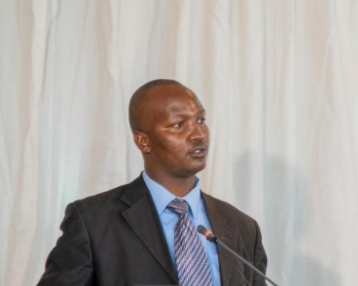 | administrator in different levels. Also worked in health services department where the department achieved a lot in terms automation of health services and Installation of internet services that supported the health systems.  Currently supporting ICT operations Nakuru City board and public service management
5. | Stephen Mucheru,  Administrator   | Stephen Mucheru Chege is the City Administrator with extensive experience in urban planning and governance. He holds an MSc in Urban Administration and Planning from the University of Seoul and a BA in Urban and Regional Planning from Maseno University. He has also completed a Senior Management Course at the Kenya School of Government.  He is a Certified Public-Private Partnership (PPP) Professional (APMG), an Associate Expert with NEMA, and a member of both the Architectural Association of Kenya (AAK) and the Kenya Institute of Planners (KIP). With over eight years of experience, he has held key roles, including Secretary of the County Project Coordination Team, Ward Administrator for Mariashoni and Lakeview Wards, and Head of the Development Control Unit at the  Nakuru County Government.
6. | Dennis Kipyator  Environmental Officer   | Dennis is an Environmental and Climate Change professional with a Master of Science in Environmental Science from Kabarak University and a Bachelor of Science in Environmental Science from Rongo University.  He has experience working with Nakuru County, Kenya National Highways Authority, Spatial Solutions Limited, and Nawiri Farm, where he has supported environmental monitoring and evaluation, reviewed Environmental Impact Assessment and Environmental Audit reports, strengthened environmental safeguards compliance, and contributed to climate change mitigation and financing initiatives.
7. | Grace Chacha  Social Safeguards Officer | Grace Chacha is an Administrative and Social Safeguards professional with over ten years of experience in public administration, healthcare coordination, and program management. She currently serves as Principal

 |  | Administrative Officer at the County Government of Nakuru, where she oversees statutory compliance, supervises project implementation, and coordinates stakeholder engagement under county development programs. She holds a Bachelor of Arts in Social Work and Community Development and has completed senior management training at the Kenya School of Government. She previously worked at Aga Khan University Hospital, Nairobi, managing insurance claims, billing, and client service operations. Grace brings strong expertise in policy analysis, official correspondence drafting, project monitoring, and records management, supported by solid administrative and digital systems proficiency.
8. | Peter Kariuki,  Supply Chain Management Officer  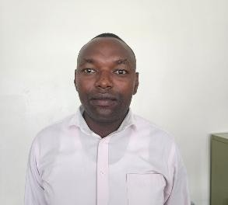 | Peter Kariuki is an organized and detail-oriented Procurement Officer with a Diploma in Supply Chain Management and registered by Kenya institute of supplies management (KISM) and in good standing with three (3) years of hands-on experience in procurement and supply chain operations. Adept at sourcing and procuring goods and services, negotiating favorable terms with suppliers, and ensuring cost-effective purchasing solutions. Possesses strong knowledge of procurement processes, inventory management, and contract administration. Skilled in utilizing procurement software to streamline workflows, manage supplier relationships, and maintain compliance with industry regulations. Highly committed to continuous improvement and operational efficiency,  with excellent problem-solving, communication, and team collaboration abilities
9. | Stanley Maina  Civil & Structural Engineer   | Eng. Stanley Macharia Maina, P.Eng., BSc., MIEK is a seasoned and innovative civil engineer, distinguished by his leadership in designing, managing, and delivering transformative infrastructure projects across Kenya. As a registered Professional Engineer with the Engineers Board of Kenya (EBK) and a corporate member of the Institution of Engineers of Kenya (IEK), Eng. Maina brings unmatched expertise in project management, technical design, and contract administration. With a proven track record in multi-million-dollar highway and urban development projects, he combines technical acumen, problem-solving, and a results-driven approach to create impactful engineering solutions. A future leader in the Association of Consulting Engineers of Kenya (ACEK), Eng. Maina is committed to fostering sustainable development, enhancing communities, and  driving innovation in engineering practices

10. | Nancy Wambugu  Human Resource Officer  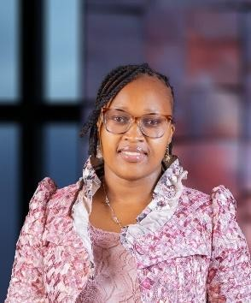 | Nancy Wakonyo Wambugu is an HRM Assistant at the Nakuru County Government, Department of Public Service and Devolution. She joined the county public service as HRM Assistant III.  She is a registered Associate Member of the Institute of Human Resource Management (IHRM), currently in good standing. She completed a Supervisory Skills Development Course at the Kenya School of Government. Nancy is proficient in Microsoft Office applications and brings strong skills in HR administration, records management, employee relations and report writing.

