NAKURU CITY BOARD MEMBERS

Serial No. | Name | Details of qualifications and experience
 | Stephen Muli  Chairperson  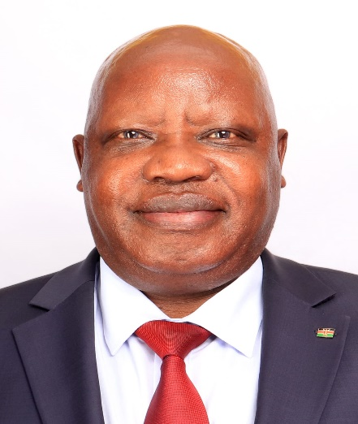 | Mr. Stephen Muli is a seasoned professional with extensive experience in leadership and management. Since 2000, he has served as Chairman of the Central Rift Matatu Owners Association, where he has played a crucial role in guiding the organization’s strategic direction and overseeing its operations. Prior to this, he was a Manager at Uchumi Supermarket from 1990 to 1995, where he excelled in staff management, budgeting, customer service, and operational efficiency.  He has a Bachelor’s degree of Commerce at the Management University of Africa, Mr. Stephen is enhancing their expertise in areas such as business law, taxation, and management of non-profit organizations. This academic pursuit complements their rich practical experience and reflects a commitment to ongoing professional development.
 | Johra Said Ali  Vice Chairperson; and  Chairperson, Finance and Administration committee   | Ms Johra Said Ali is a registered Engineer with a Master of Science in Chemical Engineering from University of KwaZulu Natal, South Africa and a B. Tech in Chemical and process engineering from Moi University. She is also pursuing a Doctor of Philosophy in Chemical Engineering from Vaal University of Technology, South Africa. She is a Lecturer at Technical University of Kenya and brings a wide scope of knowledge to the Board.  She is the Vice Chair to the City Board and Chairman of the Finance and Administration committee
 | Hon. John Kihagi  Ex-Officio member  Member, Audit, Risk and Compliance Committee  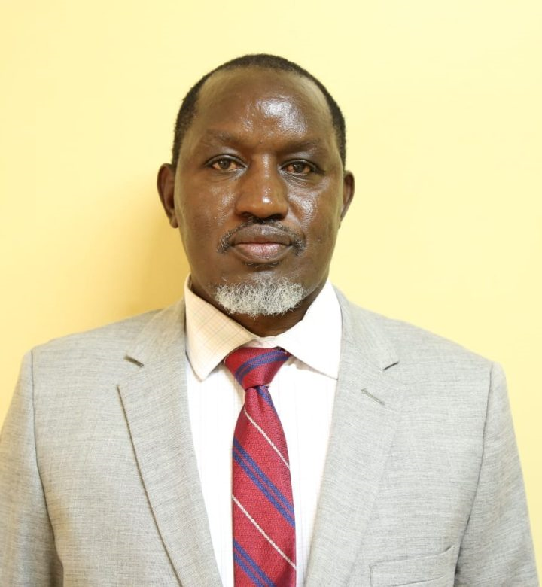 | Hon. John Karanja Kihagi is a graduate of the University of Nairobi with a Bachelor of Science in Surveying (1996) and a Master of Arts in Planning (2000). He is a registered and practicing Physical Planner, Licensed Surveyor and Environmental Impact Assessment/Audit Lead Expert. Previously, he served as the Principal Consultant at Geosurvey Engineering & Environmental Services Ltd, where he led consultancy work in Land Surveying, Physical Planning and Environmental Impact Assessment/ Audit. He has over 26 years’ post-graduation experience gained from the public service, private practice, civil society and political arenas. Mr Kihagi. He served as the Member of National Assembly representing Naivasha Constituency (2013-2017). He has also served as a Land Surveyor at the Ministry of Public Works (1997-2005) and as a Lecturer at both Jomo Kenyatta University of Agriculture and Technology (JKUAT, 2003-2005) and Kenya Institute of Surveying and Mapping (KISM, 1998-2000). He is an Ex Officio to the Board and member of audit, risk and compliance committee
 | Eng. Crispus Wathimba  Board member; and  Chairperson, Urban Planning, Environment and Infrastructure Development committee  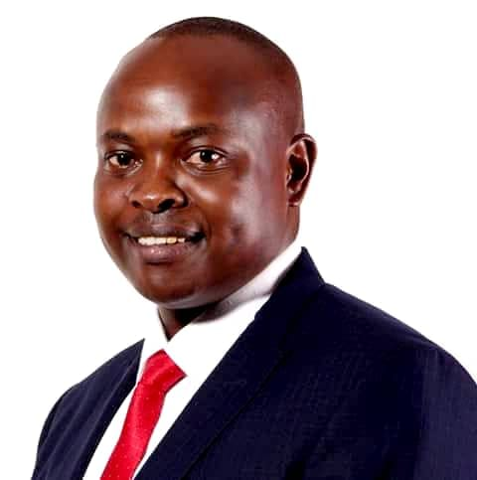 | Eng. Crispus Wathimba is a civil engineer, MBA graduate from ESAMI, and a project management professional with over 20 years of experience in infrastructure development across East Africa. His expertise spans engineering, telecommunications, renewable energy, e-mobility, and climate-smart logistics, where he has guided the design and execution of transformative projects that drive connectivity, resilience, and clean energy adoption. He is also a trusted development infrastructure advisor and serves as Chair of the Nakuru City Board Committee on Urban Planning, Infrastructure, and Environment. Crispus is recognized as a thought leader advancing climate-resilient, inclusive, and sustainable urban growth in Africa. He also serves in Finance and Administration committee.
 | James Kamau  Board Member; and  chairperson, Trade, Tourism Investment and Social Services Committee  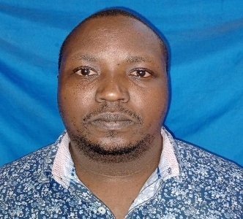 | Mr. James Kamau represents the informal sector of City residents. He holds a Bachelor of Education (Arts) from Egerton University and a technical person on business environments within the City.  Mr. James Kamau serves in the Nakuru City Board and chairs the Trade, Tourism Investment and Social Services committee, leveraging his experience in business industry to create conducive business environment in Nakuru City.
 | George Njenga  Board Member  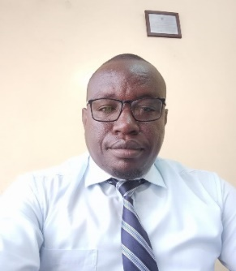 | Mr George Njenga is registered Lawyer with a Bachelor of laws Degree from Makerere University, Uganda. He has a wide and long-time experience in property law and conveyance, family law, legal research and policy review. He holds professional membership from East Africa Law Society and Rwanda Bar Association.  He is a member of the Nakuru City Board and serves in the urban planning, environment and infrastructural development; and Trade, Tourism and Social Services committees
 | Hon. Anthony Nzuki Wachira  Board Member; and  Chairperson, Audit, Risk and Compliance Committee  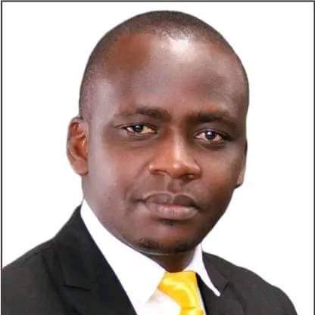 | Hon. Anthony Nzuki Wachira is an animal science specialist, with a practical experience in governance, leadership and financial management. He holds a BSc (Animal Science) (2015) and a Diploma in Animal Health (2011), both from Egerton University.  He has previously served as a Member of the County Assembly for London Ward (2021–2022) and Technical Sales Manager at Bitek Industries Limited and a Nutritionist at Bidco Oil Refineries Limited.  Hon. Nzuki serves as the Chairperson of the Audit Committee of Nakuru City Board, leveraging his legislative and financial oversight experience to strengthen financial management of the City Board.
 | Julie Wanjiru Chege  Board Member  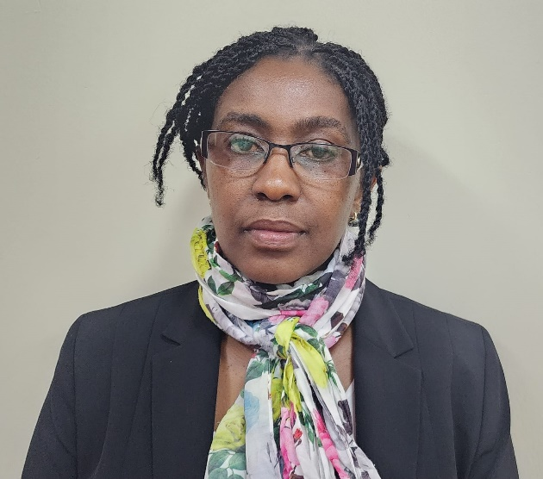 | Ms. Julie Wanjiru Chege is a seasoned business person, with over 20 years’ experience in business leadership, events management, hospitality, and governance. She is the founder and Director of Ashley’s Events Ltd, The Fresh Market & Café, and Ashley’s Events Institute. She is a business development and management mentor and corporate governance and accountability trainer.  Julie Wanjiru holds a Bachelor of Arts in Mass Media and Communication (Public Relations), First Class Honours – Mount Kenya University, Diploma in Office Administration, Pitman Qualification (First Class) and Certificate in Non-Profit Leadership and Compliance – CESRA.  She is a serving as a member of Finance and Administration; and Trade, tourism investment and social Service committees of the Nakuru City Board.
 | Adrienne Wangari Murigu,  Board Member   | Ms Adrienne Wangari Murigu is a graduate of International Trade and Economics from Shanghai Lixin University of Accounts and Finance. She is the acting Director of Tiankara Creations, a third-generation cloth-line manufacturing enterprise in Nakuru.  She serves as board member in Nakuru City Board, bringing dynamic and transformative approach to urban governance and planning. She serves as a member in Finance and Administration committee, as well as Trade, Tourism and Social Services Committee.
10. | Arch. O’ Wakwabi, Odhiambo Zebedy  Board Member  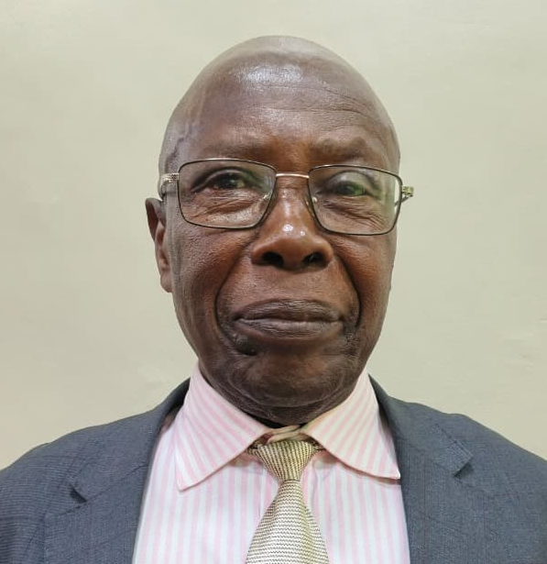 | Arch. Zebedy O’Wakwabi is a seasoned architect, currently a principal consultant at O’wakwabi and Associates since 1997. He previously worked at the ministry of public works, raising from assistant architect in 1980, and raise in ranks up to the provincial architect in 1988 to the time he left public service.  He holds degree in architecture from University of Nairobi and registered by the Board of Registration of Architects and Quantity Surveyors of Kenya (BORAQS).  Arch. Zebedy O’Wakwabi has made immense contribution in community development through chairing several schools boards of management and church councils, notably; Musanda Secondary School, ACK Cathedral among others.  He serves in Nakuru City Board and a member in the city board’s infrastructure and trade committees.
11. | Linda Chepkorir Munyao  Board Member  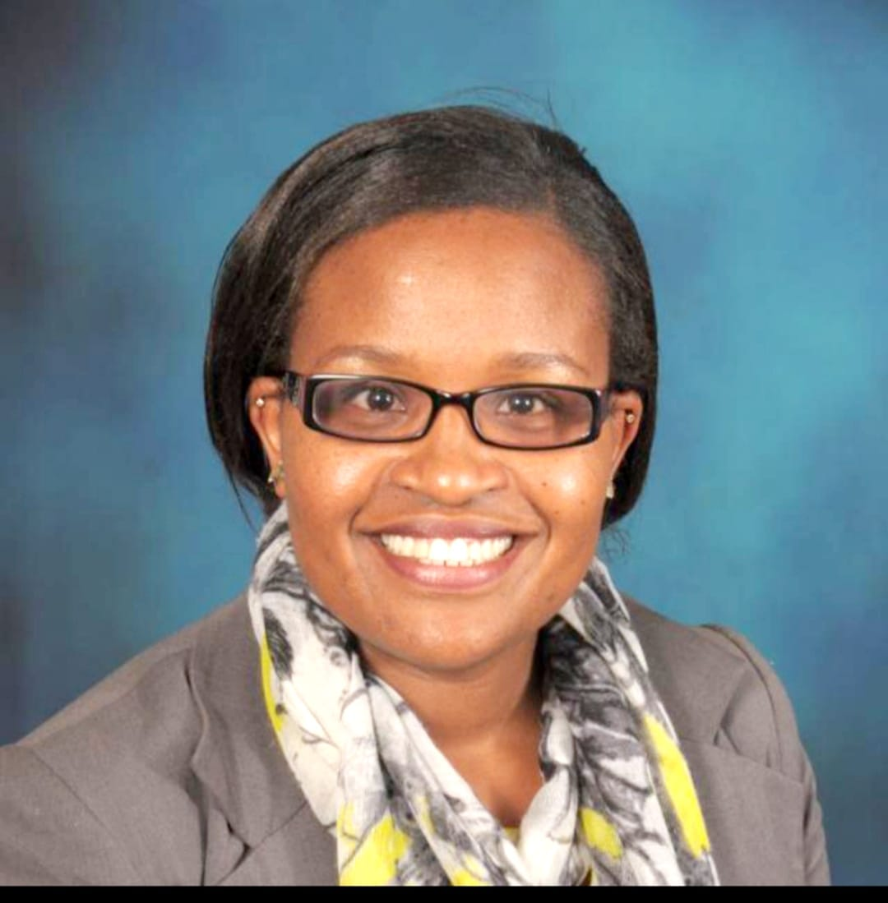 | Ms. Linda Chepkorir Munyao holds an MSc in Biodiversity & Conservation from the University of Leeds in the UK, a BSc in Environmental Studies from Maseno University and a Diploma in International Environmental Law from the UN Institute for Training and Research, (Switzerland).  She is registered as a Lead Expert in Environmental Impact Assessment and Environmental Audit by NEMA and is an Accredited lead auditor of the Sustainable Agriculture Standards for Rainforest Alliance Certified™ program, trained Lead Auditor for ISO 14000:2004 (Environment Management Systems) and ISO 9001:2015 (Quality Management Systems).  Linda has extensive experience in the field of environmental management and sustainability auditing having worked in the private sector and consultancy practice in the last 20 years.  Ms. Linda Ruto Munyao is a member of the Urban Planning, Environment & Infrastructure Development Committee. She is also a member of the Finance and Administration Committee.
12. | Gitau Thabanja  Secretary to the Board  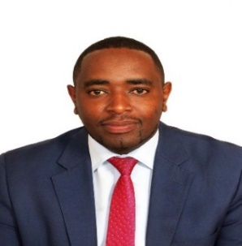 | Mr Gitau Thabanja is the City Manager, Secretary and the accounting officer to the Board. He implements the Board`s resolutions and also oversees the management and affairs of the city.  He is an Urban Planner, with a Master’s degree in Urban Administration and Planning from the esteemed University of Seoul, South Korea. He holds a Bachelor of Education – B.Ed. (Economics and Business Studies) from Kenyatta University.  He has also been a CECM Land, Housing, and Physical Planning, Nyandarua County.

